Common Scenario: Student Course Registration System
Database Schema — Relational (PostgreSQL / MySQL)
Create a database named college_db. Use the following tables throughout all exercises.
MYSQL
Query:-
CREATE TABLE departments (
department_id INT AUTO_INCREMENT PRIMARY KEY,
dept_name VARCHAR(100) NOT NULL,
hod_name VARCHAR(100),
budget DECIMAL(12,2)
);
CREATE TABLE students (
student_id INT AUTO_INCREMENT PRIMARY KEY,
first_name VARCHAR(50) NOT NULL,
last_name VARCHAR(50) NOT NULL,
email VARCHAR(100) NOT NULL UNIQUE,
date_of_birth DATE,
department_id INT,
enrollment_year INT,
FOREIGN KEY (department_id) REFERENCES departments(department_id)
);
CREATE TABLE courses (
course_id INT AUTO_INCREMENT PRIMARY KEY,
course_name VARCHAR(150) NOT NULL,
course_code VARCHAR(20) UNIQUE,
credits INT,
department_id INT,
FOREIGN KEY (department_id) REFERENCES departments(department_id)
);
CREATE TABLE professors (
professor_id INT AUTO_INCREMENT PRIMARY KEY,
prof_name VARCHAR(100) NOT NULL,
email VARCHAR(100) UNIQUE,
department_id INT,
salary DECIMAL(10,2),
FOREIGN KEY (department_id) REFERENCES departments(department_id)
);
CREATE TABLE enrollments (
enrollment_id INT AUTO_INCREMENT PRIMARY KEY,
student_id INT,
course_id INT,
enrollment_date DATE,
grade CHAR(2),
FOREIGN KEY (student_id) REFERENCES students(student_id),
FOREIGN KEY (course_id) REFERENCES courses(course_id)
);

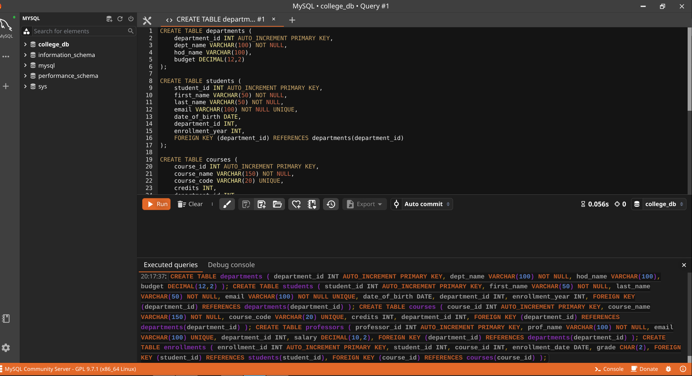
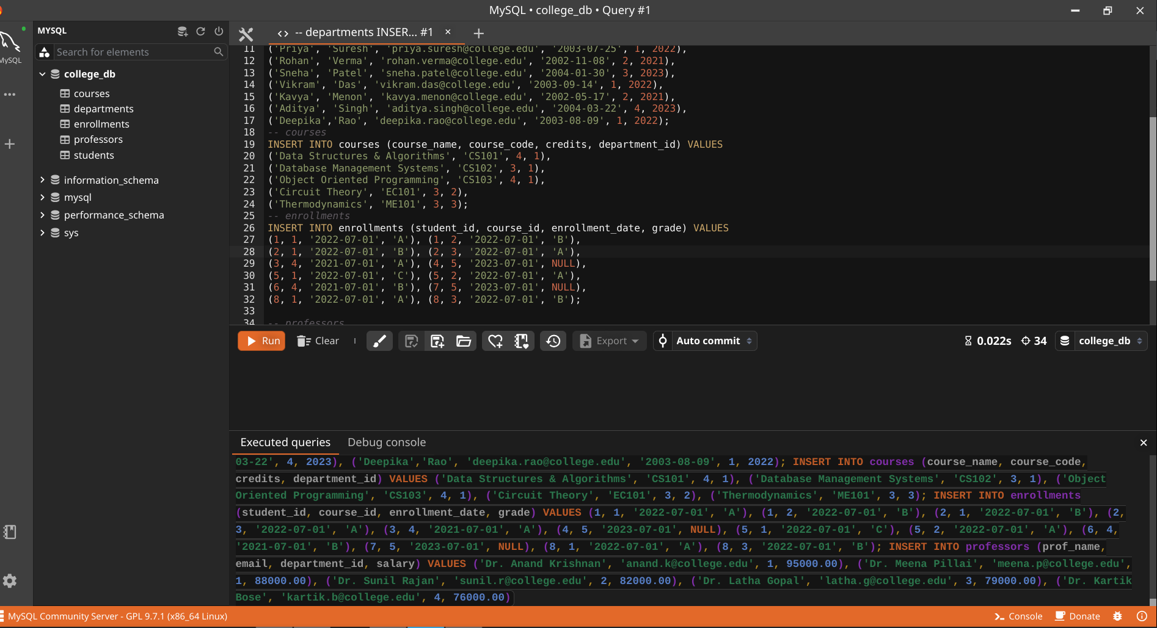
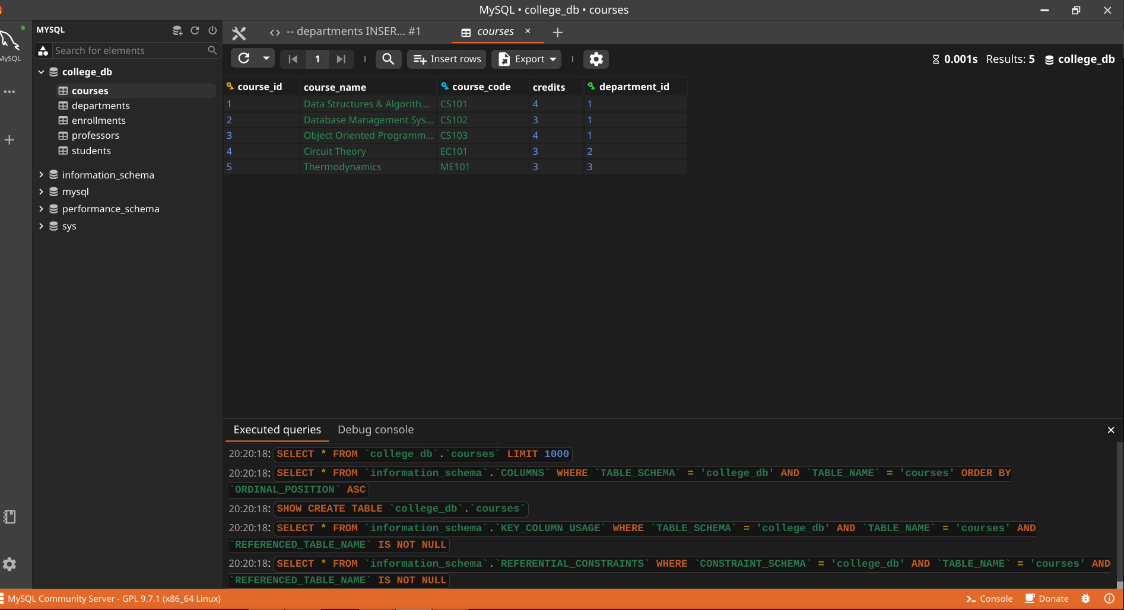
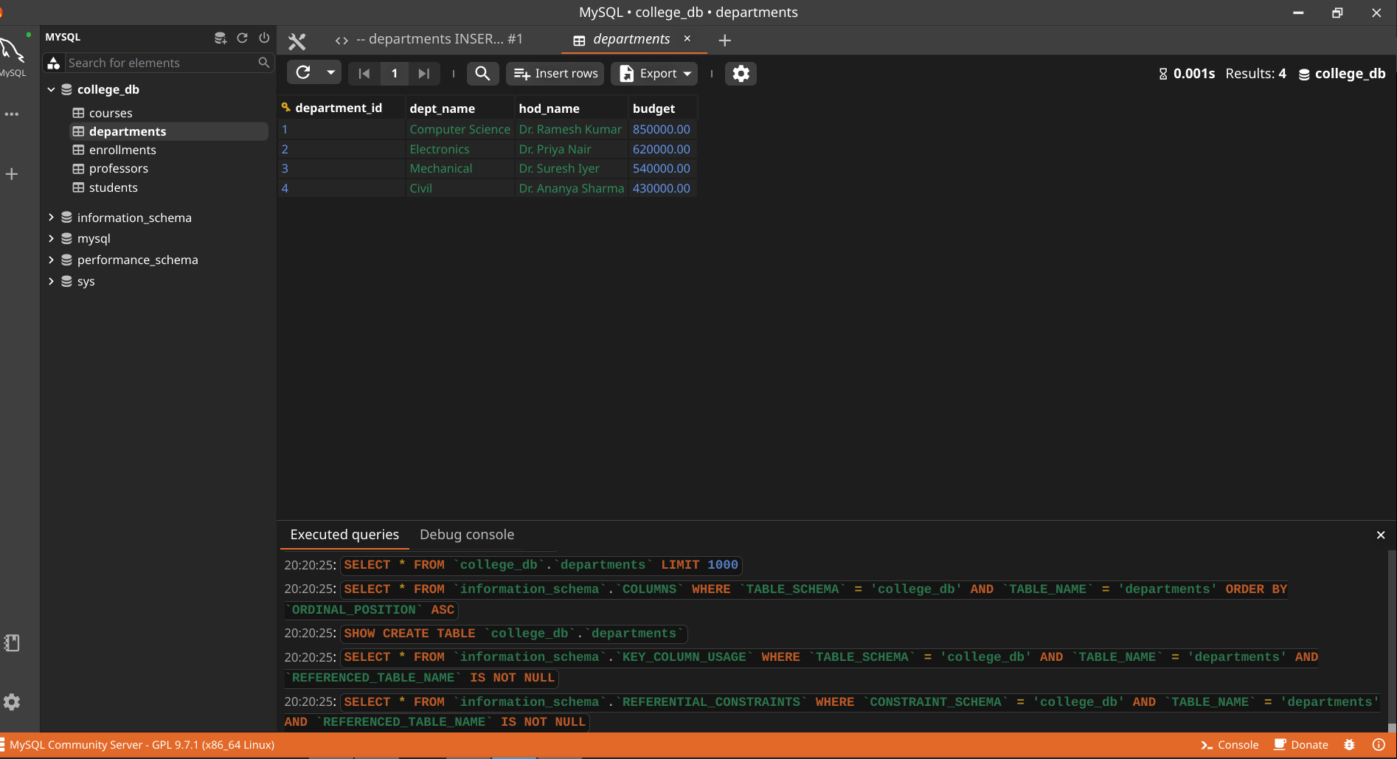
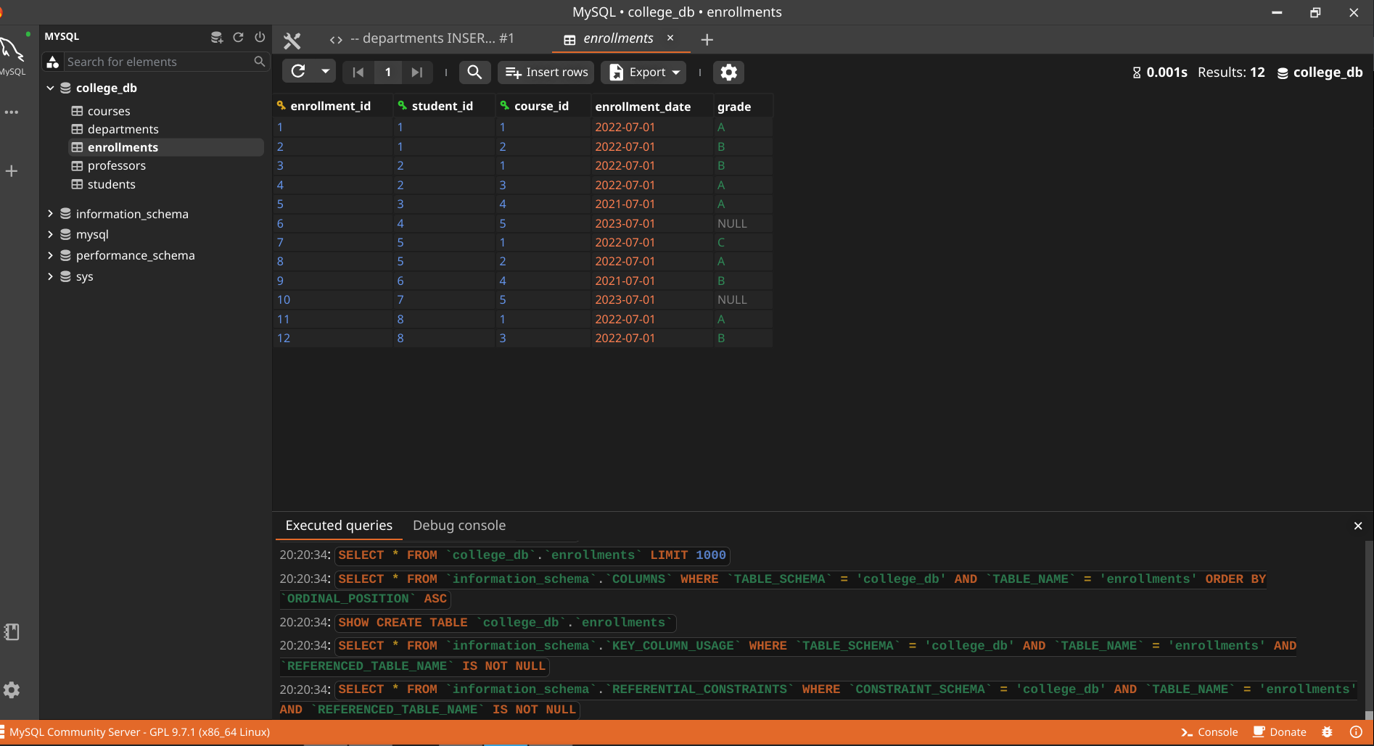
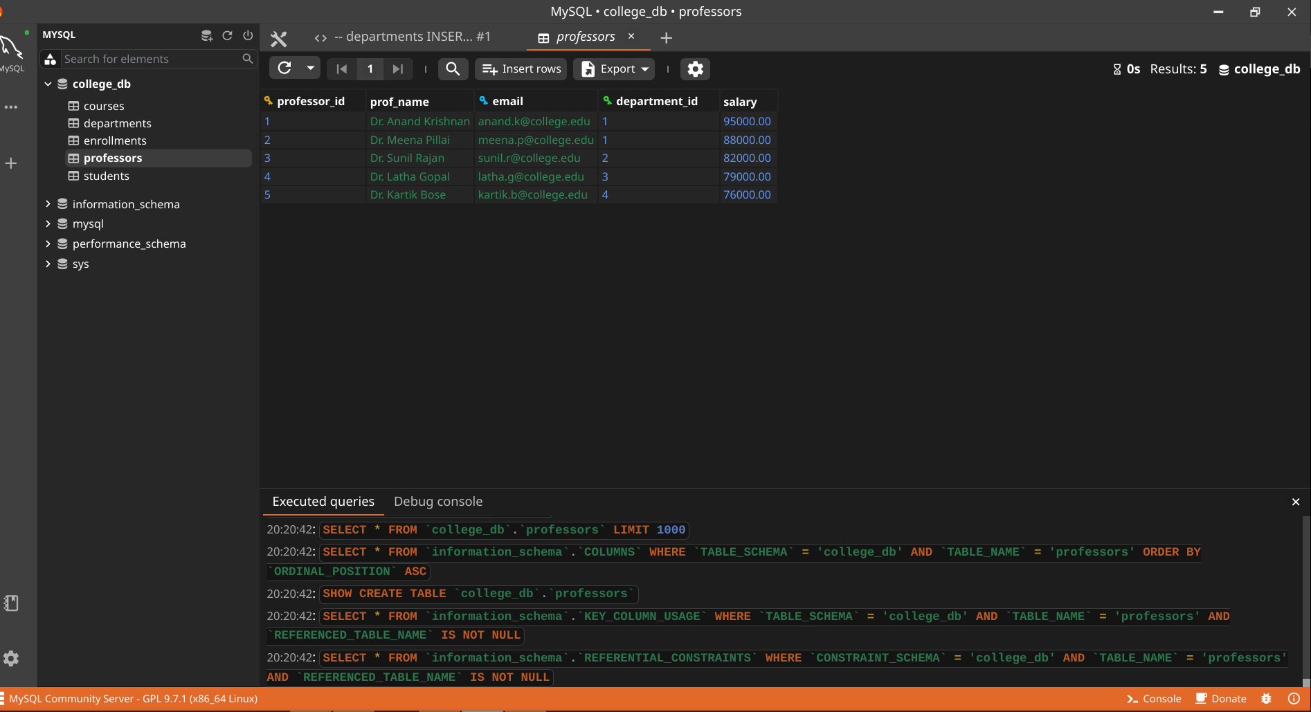
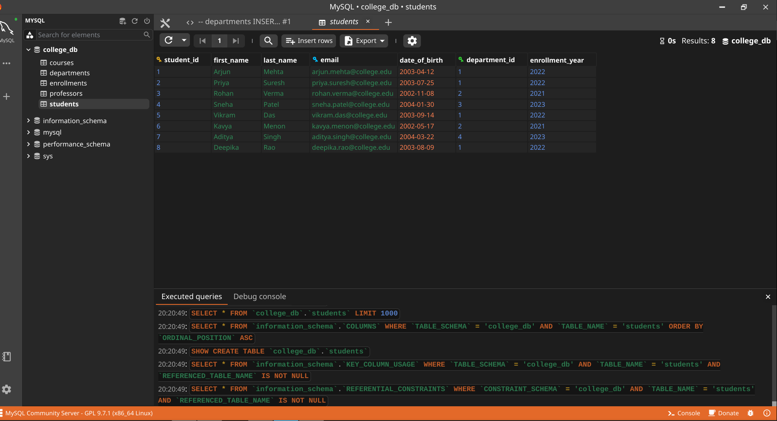

POSTGRE

CREATE TABLE departments (
department_id INT GENERATED ALWAYS AS IDENTITY PRIMARY KEY,
dept_name VARCHAR(100) NOT NULL,
hod_name VARCHAR(100),
budget DECIMAL(12,2)
);

CREATE TABLE students (
student_id INT GENERATED ALWAYS AS IDENTITY PRIMARY KEY,
first_name VARCHAR(50) NOT NULL,
last_name VARCHAR(50) NOT NULL,
email VARCHAR(100) NOT NULL UNIQUE,
date_of_birth DATE,
department_id INT,
enrollment_year INT,
FOREIGN KEY (department_id) REFERENCES departments(department_id)
);

CREATE TABLE courses (
course_id INT GENERATED ALWAYS AS IDENTITY PRIMARY KEY,
course_name VARCHAR(150) NOT NULL,
course_code VARCHAR(20) UNIQUE,
credits INT,
department_id INT,
FOREIGN KEY (department_id) REFERENCES departments(department_id)
);

CREATE TABLE professors (
professor_id INT GENERATED ALWAYS AS IDENTITY PRIMARY KEY,
prof_name VARCHAR(100) NOT NULL,
email VARCHAR(100) UNIQUE,
department_id INT,
salary DECIMAL(10,2),
FOREIGN KEY (department_id) REFERENCES departments(department_id)
);

CREATE TABLE enrollments (
enrollment_id INT GENERATED ALWAYS AS IDENTITY PRIMARY KEY,
student_id INT,
course_id INT,
enrollment_date DATE,
grade CHAR(2),
FOREIGN KEY (student_id) REFERENCES students(student_id),
FOREIGN KEY (course_id) REFERENCES courses(course_id)
);

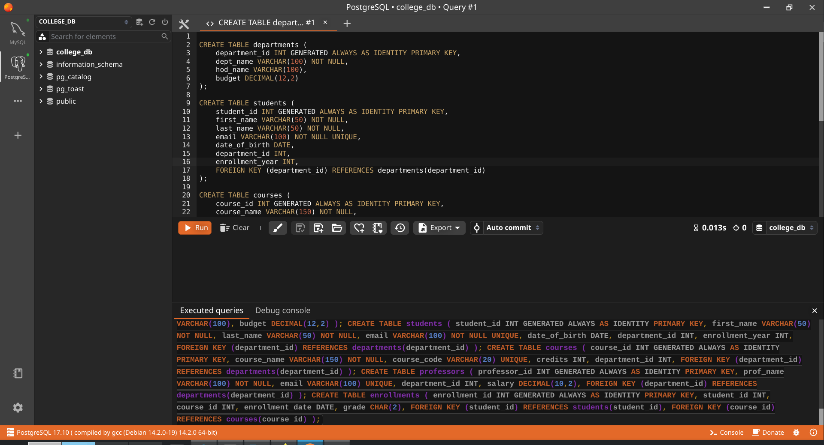
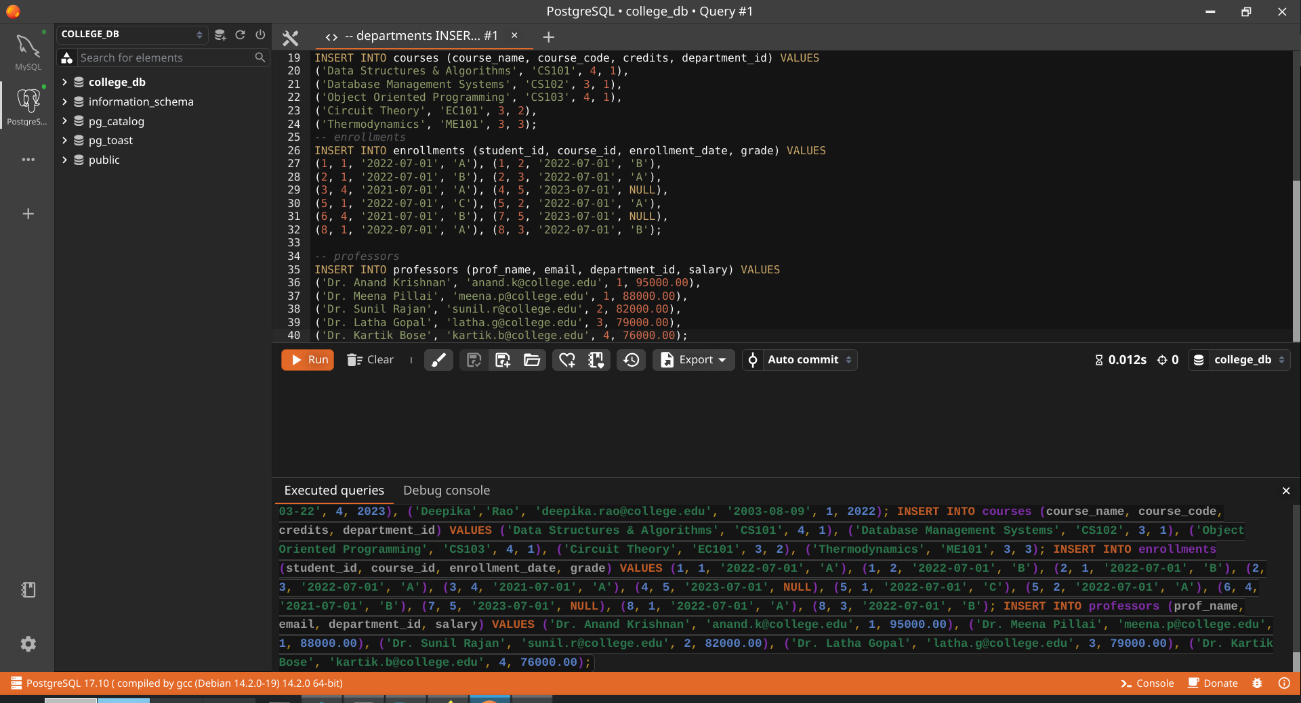
HANDS-ON 1
Schema Design & Core SQL — DDL and Normalisation
Task 1: Create the Database and Tables

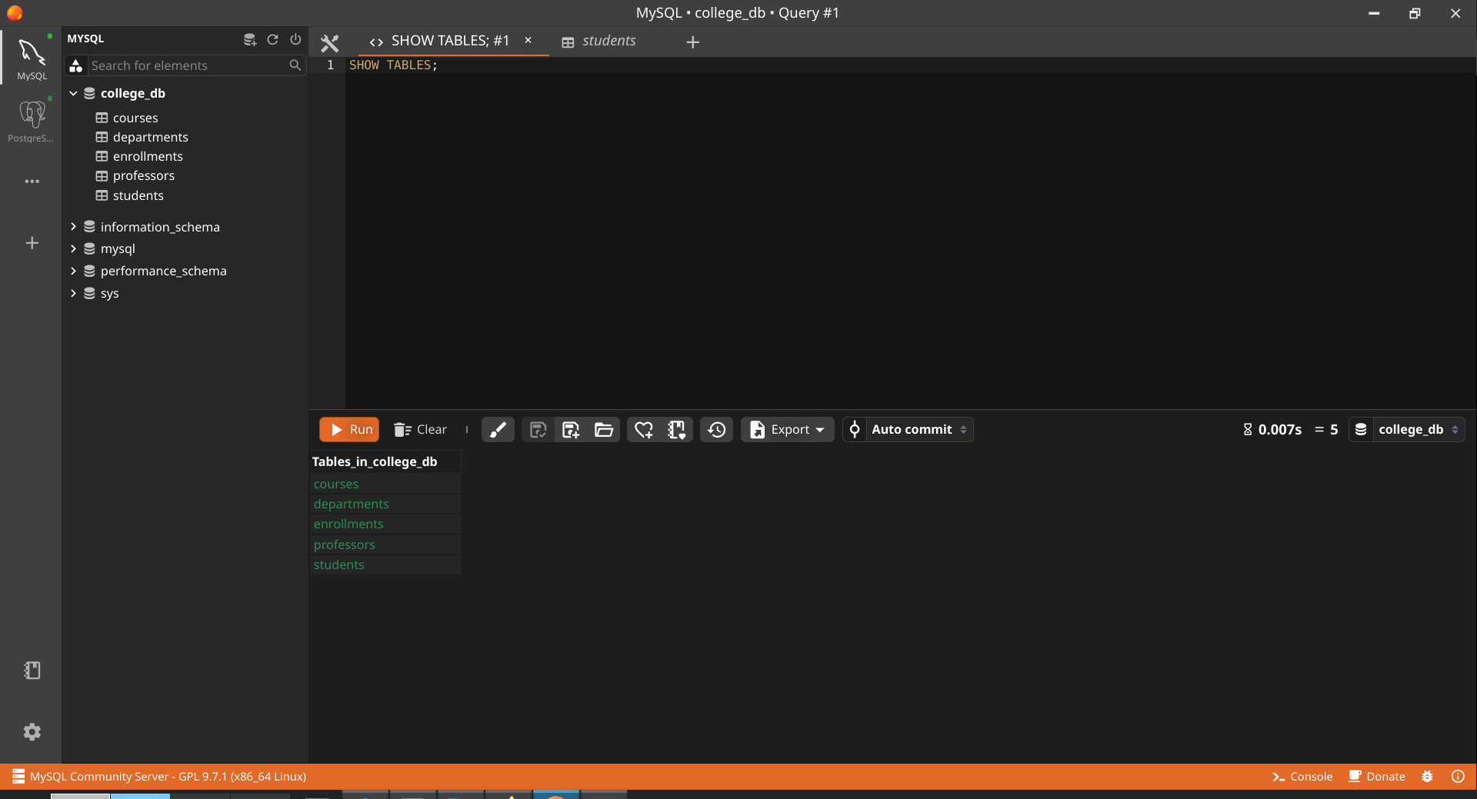

Task 2: Verify Normalisation

